**TASK**

1. Write a note on array methods in javascript with example. **Note:You should find all the methods and try to implement them.**

Explanation:

* Push():The push() method adds a new element to an array (at the end) The push() method returns the new array length:

Eg:

let fruits = ['apple', 'banana']; let newLength = fruits.push('orange'); // fruits is now ['apple', 'banana', 'orange'] // newLength is 3

* Pop():Removes the last element from an array and returns that element. The pop() method removes the last element from an array.

Eg: let fruits = ['apple', 'banana', 'orange'];

let lastFruit = fruits.pop();

// fruits is now ['apple', 'banana']

// lastFruit is 'orange'

* Shift() : The shift() method removes the first array element and "shifts" all other elements to a lower index. The shift() method returns the value that was "shifted out"

Eg:

let fruits = ['apple', 'banana', 'orange'];

let firstFruit = fruits.shift();

// fruits is now ['banana', 'orange']

// firstFruit is 'apple'

* Unshift(): The unshift() method adds a new element to an array (at the beginning), and "unshifts" older elements:

Eg:

let fruits = ['banana', 'orange'];

let newLength = fruits.unshift('apple');

// fruits is now ['apple', 'banana', 'orange']

// newLength is 3

* Concat()

The concat() method creates a new array by merging (concatenating) existing arrays. The concat() method does not change the existing arrays. It always returns a new array.The concat() method can take any number of array arguments.

Eg:

let fruits = ['apple'];

let moreFruits = fruits.concat(['banana', 'orange']);

// moreFruits is ['apple', 'banana', 'orange'].

* Slice()

The slice() method slices out a piece of an array into a new array. The slice() method creates a new array.The slice() method does not remove any elements from the source array.

Example:

let fruits = ['apple', 'banana', 'orange', 'peach'];

let citrus = fruits.slice(2);

// citrus is ['orange', 'peach'], fruits remains unchanged

* Splice()

The splice() method adds new items to an array.

Changes the contents of an array by removing or replacing existing elements and/or adding new elements.

Example

let fruits = ['apple', 'banana', 'orange'];

fruits.splice(1, 1, 'grape', 'melon');

// fruits is now ['apple', 'grape', 'melon', 'orange']

* forEach()

Executes a provided function once for each array element.

Example

let fruits = ['apple', 'banana', 'orange'];

fruits.forEach(function(fruit) { console.log(fruit); });

// Logs: 'apple', 'banana', 'orange'

* filter()

Creates a new array with all elements that pass the test implemented by the provided function.

Example:

let numbers = [1, 2, 3, 4, 5];

let evens = numbers.filter(function(num) {

return num % 2 === 0;

});

// evens is [2, 4], numbers remains unchanged

1. Create an array of numbers and add numbers to this array and Keep adding numbers to the array in the even number format.

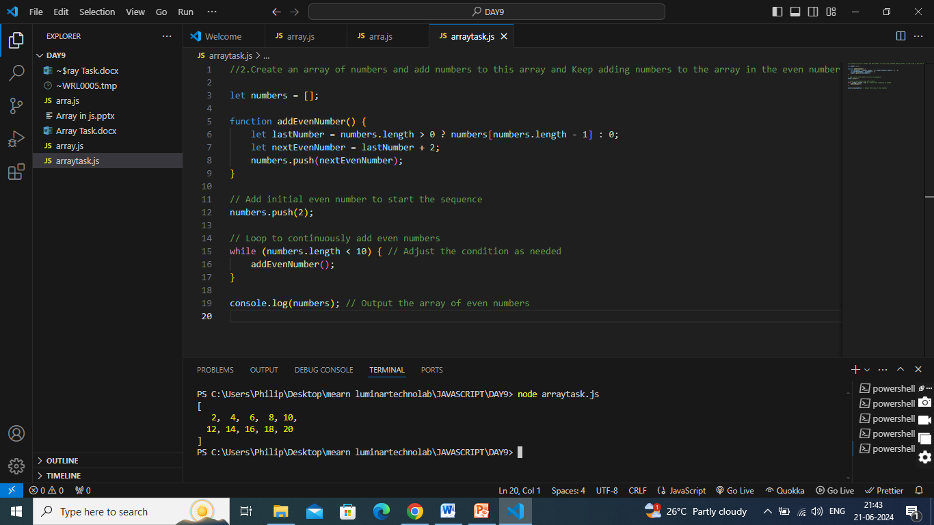

1. filter the numbers divisible by 10 from a given array Eg: [10,25,67,45,70,36,50]

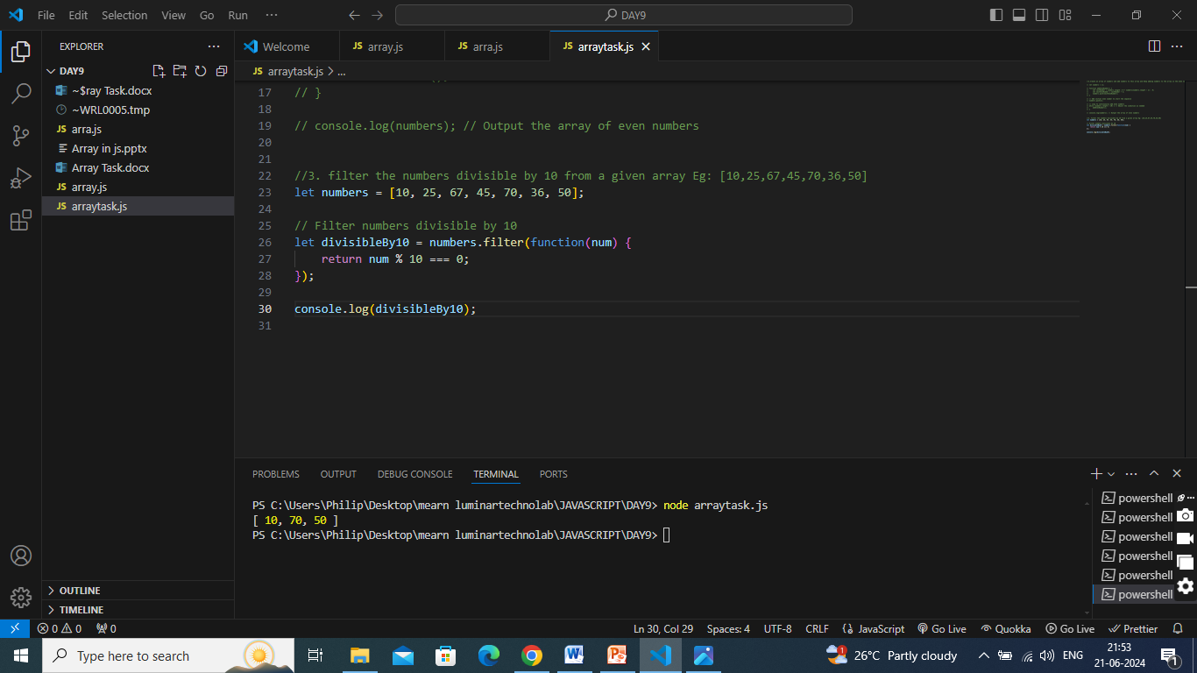

1. Create an array of square of given number eg: [3,4,5,6,7]

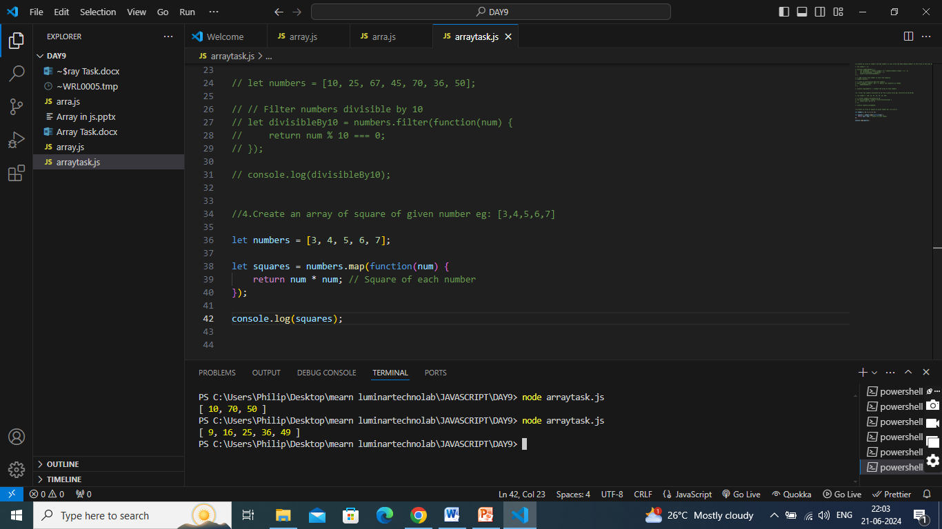

1. Write a function to remove all duplicate elements from an array

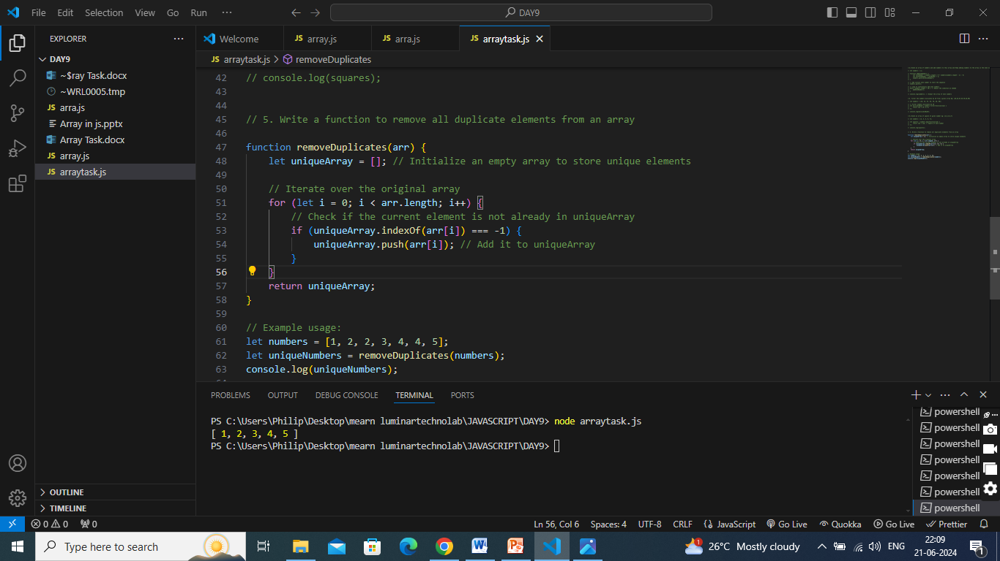

1. Write a function to reverse an array in-place (without creating a new array).

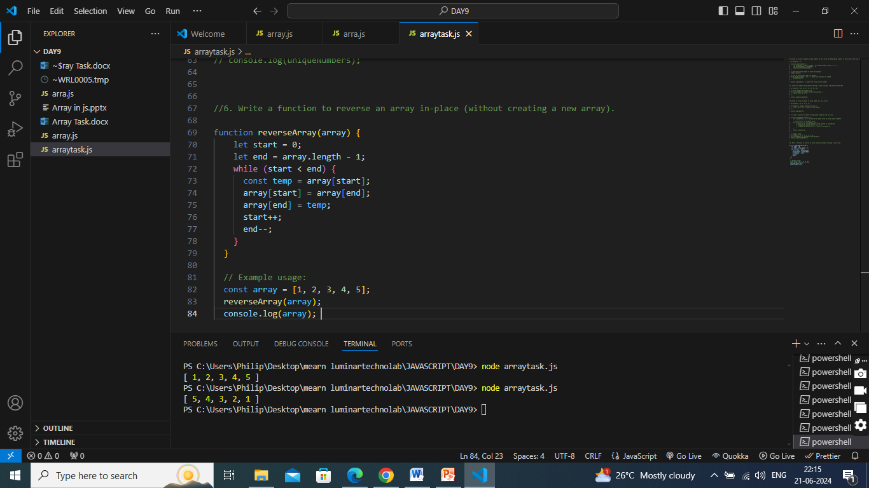

1. Write a function to find the intersection of two arrays

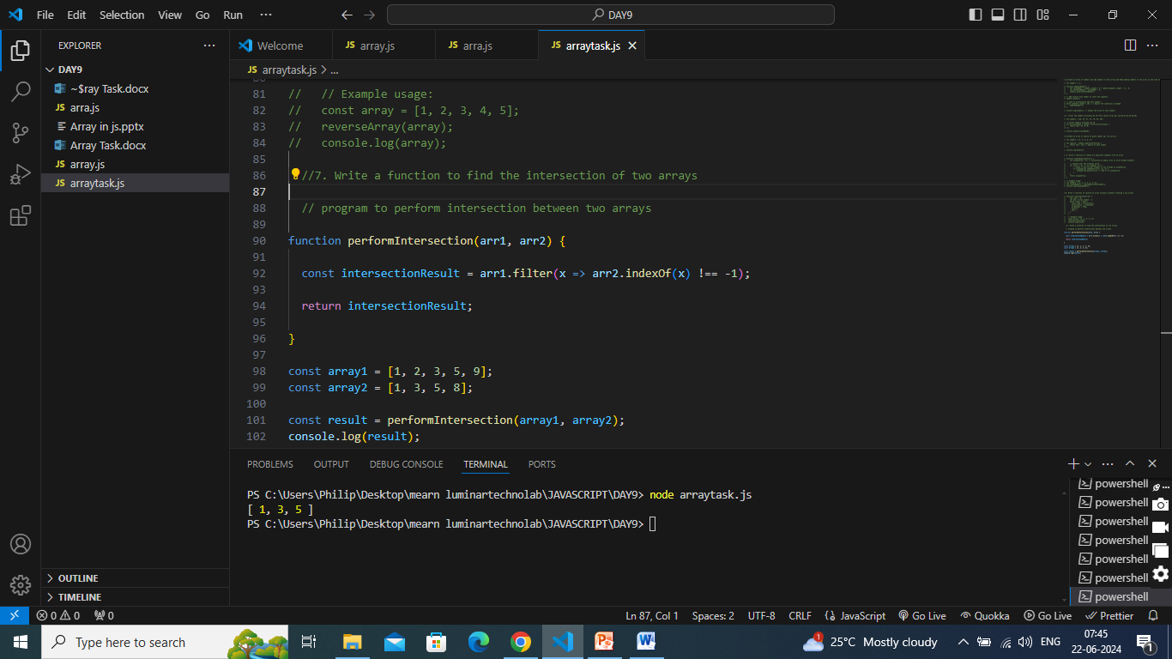

1. Write a function to remove all falsy values (e.g., null, undefined, 0, false) from an array.

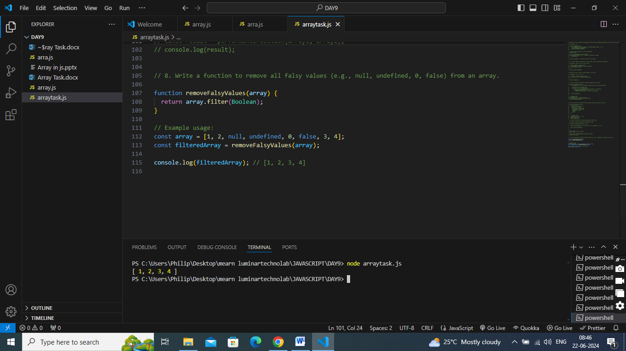

1. Write a function to shuffle the elements of an array randomly.

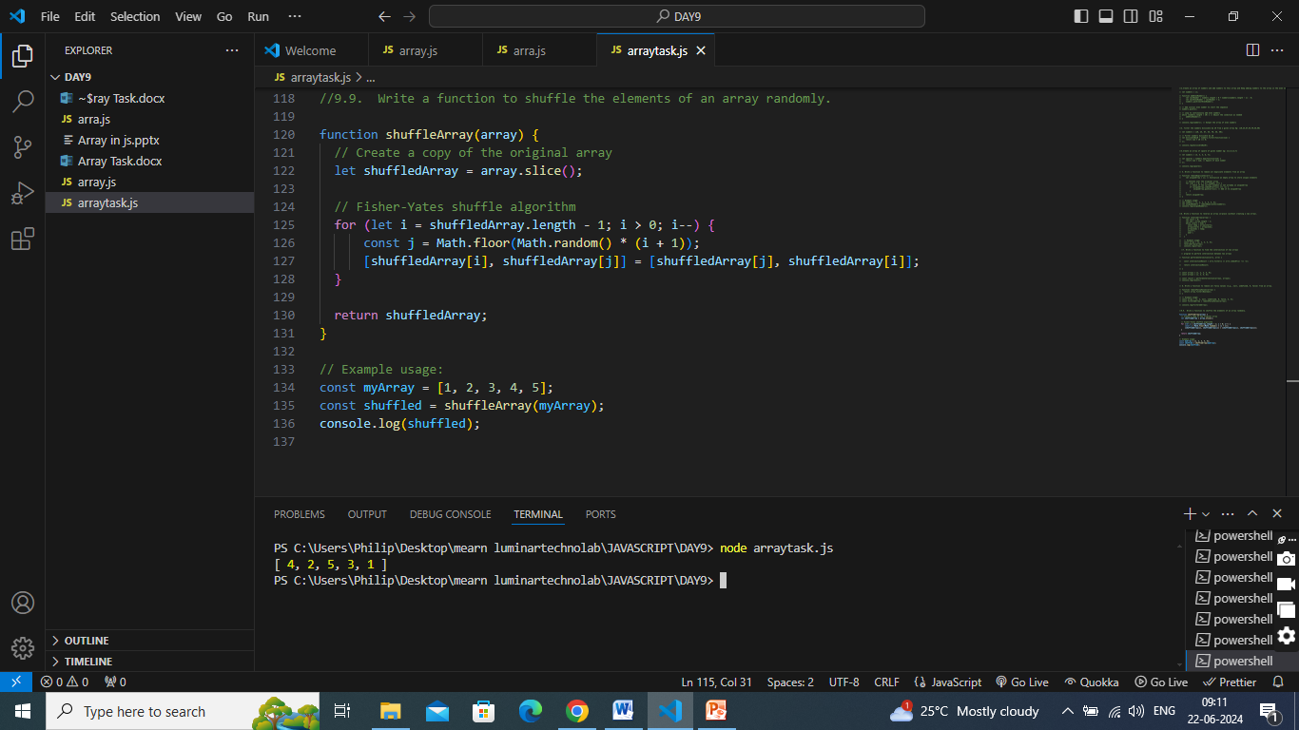

1. Write a function to find the difference between two arrays (elements in one array but not in the other).

